**Content**

1. Nadpis 1 3

1. CodeWars
   1. any() all()

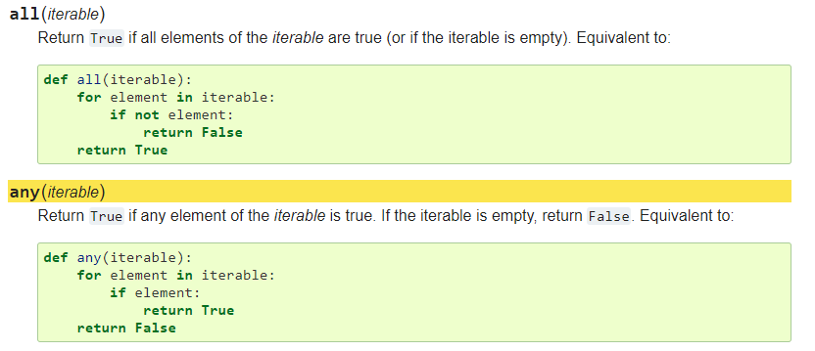



* 1. Lambda functions in Python

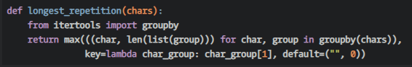

* 1. Query json

def findkeys(node, kv):

   if isinstance(node, list):

       for i in node:

           for x in findkeys(i, kv):

              yield x

   elif isinstance(node, dict):

       if kv in node:

           yield node[kv]

       for j in node.values():

           for x in findkeys(j, kv):

               yield x